PRINTS-A000-EUR-Italy-Rome-Tiber Island-Atlas-1893

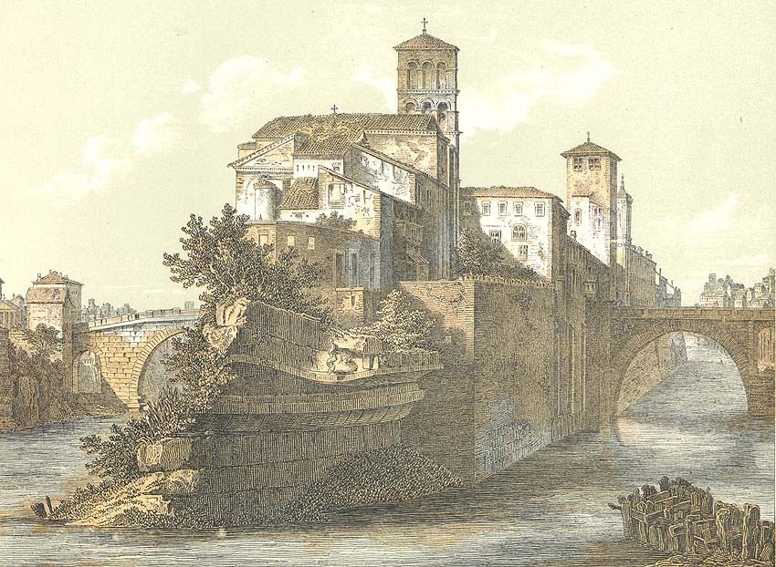

**PRINT DATE:** This antique print is from an old German atlas published in 1893. .

**PRINT SIZE:** Overall print size is 9 1/2 inches by 12 1/2 inches including white borders which amount to about an inch on each side.

The Tiber Island (Italian: Isola Tiberina; Latin: Insula Tiberina) is a boat-shaped island in the southern bend of the Tiber river in Rome. Approximately 270 m in length and 67 m at its widest, the island is well-known for being the site of an ancient temple to Aesculapius, the Greek god of medicine and healing. Legend has it that after the fall of the hated ruler Tarquinius Superbus (510 BC), the angry people threw his body into the Tiber. It settled onto the bottom, where dirt and silt accumulated around it. Another version of the legend is that the people gathered up the wheat and grain of their despised ruler and threw it into the Tiber, where it served as the foundation of the island. Owing to its dark origins, the Tiber Island was considered a place of ill omen. Until the temple was built, nobody went onto the island, and only the worst criminals were condemned to pass the remainder of their lives on the island. The island's boat shape is what remains of the great temple which once stood there. Accounts say that in 293 BC, there was a great plague in Rome. Upon consulting the Sibyl, the Roman Senate was instructed to build a temple to Aesculapius, the Greek god of healing, and promptly sent a delegation to obtain a statue of the deity. Upon its return trip up the Tiber river, a snake (a symbol of Aesculapius) was seen slithering off the ship and swimming onto the island. This was seen as the god's own choice for his temple's location, and the temple was built on the island, thus ending the plague. The location for healing was choosen for it being separated from the rest of the city. The island eventually became so identified with the temple that, as a reminder of the miraculous event, it was modeled to resemble a Ship. Travertine facing resembling a ship's prow and stern were added by the banks, and an obelisk was erected in the middle, symbolizing the vessel's mast. Walls were put around it, so that the island actually came to resemble a Roman ship. In the Christian age the obelisk was replaced by a column with a cross on the top. After it was destroyed in 1867 Pope Pius IX had an aedicula, called Spire, put in its place. This monument, deisgned by [Ignazio Giacometti]], is decorated with the statues of the four saints related to island: St. Bartholomew, St. Paulinus of Nola, St. Francis and St. John. Although little of the temple remains, the island is still a place of healing, as a modern-day hospital (Fatebenefratelli Hospital) stands on the western section of the island. In 998 Emperor Otto III had a new San Bartolomeo all'Isola built over the temple's ruins in . This was entitled to his friend, the martyr Adalbert of Prague. The name of St. Bartholomew was added later, but today the church is popularly known simply as San Bartolomeo all'Isola.

Sold for:

**US $17.99**